* + 1. Use Case

[Table 13] Use case of open own bookmark table

| **Use case name** | **Register** |
| --- | --- |
| Actor | Instructor and Learner |
| Description | It is a process when an instructor and learner tries to open their own bookmark table |
| Normal Course | 1. All the users can see their bookmark table bar under the video 2. The user click the button that is in bookmark table bar 3. The system check database about bookmark and show bookmark data in database, bookmark flag and buttons to control bookmark. The data and buttons includes    1. Bookmark id    2. Bookmark time    3. Bookmark note    4. Make bookmark button    5. Edit bookmark button    6. Delete bookmark button |
| Precondition | The user is in the lecture page that conclude video  In case of there are no data in database, the system show nothing to page |
| Post Condition | N/A |
| Assumptions | The user want to see their own bookmark table. |

[Table 13] Use case of make bookmark

| **Use case name** | **Register** |
| --- | --- |
| Actor | Instructor and Learner |
| Description | It is a process when an instructor and learner tries to make bookmark. |
| Normal Course | 1. All the users can see bookmark button when users open bookmark table 2. The user click the “make bookmark” button 3. The system check the time of video and add new row in bookmark table to show new bookmark data to user |
| Precondition | The user is in the lecture page that conclude video  The bookmark table is opened |
| Post Condition | The data about new bookmark should save at database |
| Assumptions | The user want to add new bookmark |

[Table 13] Use case of jump to bookmark

| **Use case name** | **Register** |
| --- | --- |
| Actor | Instructor and Learner |
| Description | It is a process when an instructor and learner tries to jump to bookmark. |
| Normal Course | 1. All the users can see bookmark time in bookmark table 2. The user click the “bookmark time” 3. The system show the video at "bookmark time” |
| Precondition | The user is in the lecture page that conclude video  The bookmark table is opened  There is at least one bookmark in bookmark table |
| Post Condition | N/A |
| Assumptions | The user want to jump to bookmark |

[Table 13] Use case of edit bookmark

| **Use case name** | **Register** |
| --- | --- |
| Actor | Instructor and Learner |
| Description | It is a process when an instructor and learner tries to edit bookmark. |
| Normal Course | 1. All the users can see “edit bookmark” button when users open bookmark table 2. The user click the “edit bookmark” button 3. The system change the modifiability of data. The data includes    1. Time data    2. Note (if there is a note) 4. The system show several buttons. The buttons includes    1. "add note” button if there is no note with bookmark    2. "delete note” button if there is a note    3. "finish edit” button 5. The user can change the content of time data and note 6. The user can delete note by click the "delete note” button 7. The system show bookmark table page after user click the "finish edit” button |
| Precondition | The user is in the lecture page that conclude video  The bookmark table is opened  There is at least one bookmark in bookmark table |
| Post Condition | The changed data about time and note are save at database |
| Assumptions | The user want to change the data of bookmark |

[Table 13] Use case of add note

| **Use case name** | **Register** |
| --- | --- |
| Actor | Instructor and Learner |
| Description | It is a process when an instructor and learner tries to add note |
| Normal Course | 1. All the users can see “add note” button when users click the "edit bookmark” button if there are some bookmark with no note 2. The user click the “add note” button 3. The system add new row under the bookmark that user want to add note. The new row is modifiable. 4. The user can write content in new row 5. The system show bookmark table page after user click the "finish edit” button |
| Precondition | The user is in the lecture page that conclude video  The bookmark table is opened  There is at least one bookmark in bookmark table  There is at least one bookmark with no note |
| Post Condition | The note data are save at database |
| Assumptions | The user want to add note |

[Table 13] Use case of delete bookmark

| **Use case name** | **Register** |
| --- | --- |
| Actor | Instructor and Learner |
| Description | It is a process when an instructor and learner tries to delete bookmark |
| Normal Course | 1. All the users can see “delete bookmark” button when users open bookmark table 2. The user click the “delete bookmark” button 3. The system show "delete” button on the right side of bookmarks and one "finish delete” button 4. The user can click the "delete” button to delete the bookmark 5. The user can delete note by click the "delete note” button 6. The system show bookmark table page after user click the "finish delete” button |
| Precondition | The user is in the lecture page that conclude video  The bookmark table is opened  There is at least one bookmark in bookmark table |
| Post Condition | The delete the data in database |
| Assumptions | The user want to delete bookmark |

[Table 13] Use case of open instrucor's bookmark

| **Use case name** | **Register** |
| --- | --- |
| Actor | Learner |
| Description | It is a process when an instructor and learner tries to open instructor's bookmark |
| Normal Course | 1. All the users can see their bookmark table bar under the video 2. The user click the button that is in bookmark table bar 3. The system check database about bookmark and show bookmark data in database and bookmark flag. The data includes    1. Bookmark id    2. Bookmark time    3. Bookmark note |
| Precondition | The user is in the lecture page that conclude video  In case of there are no data in database, the system show nothing to page |
| Post Condition | N/A |
| Assumptions | The user want to see instructor's bookmark table. |

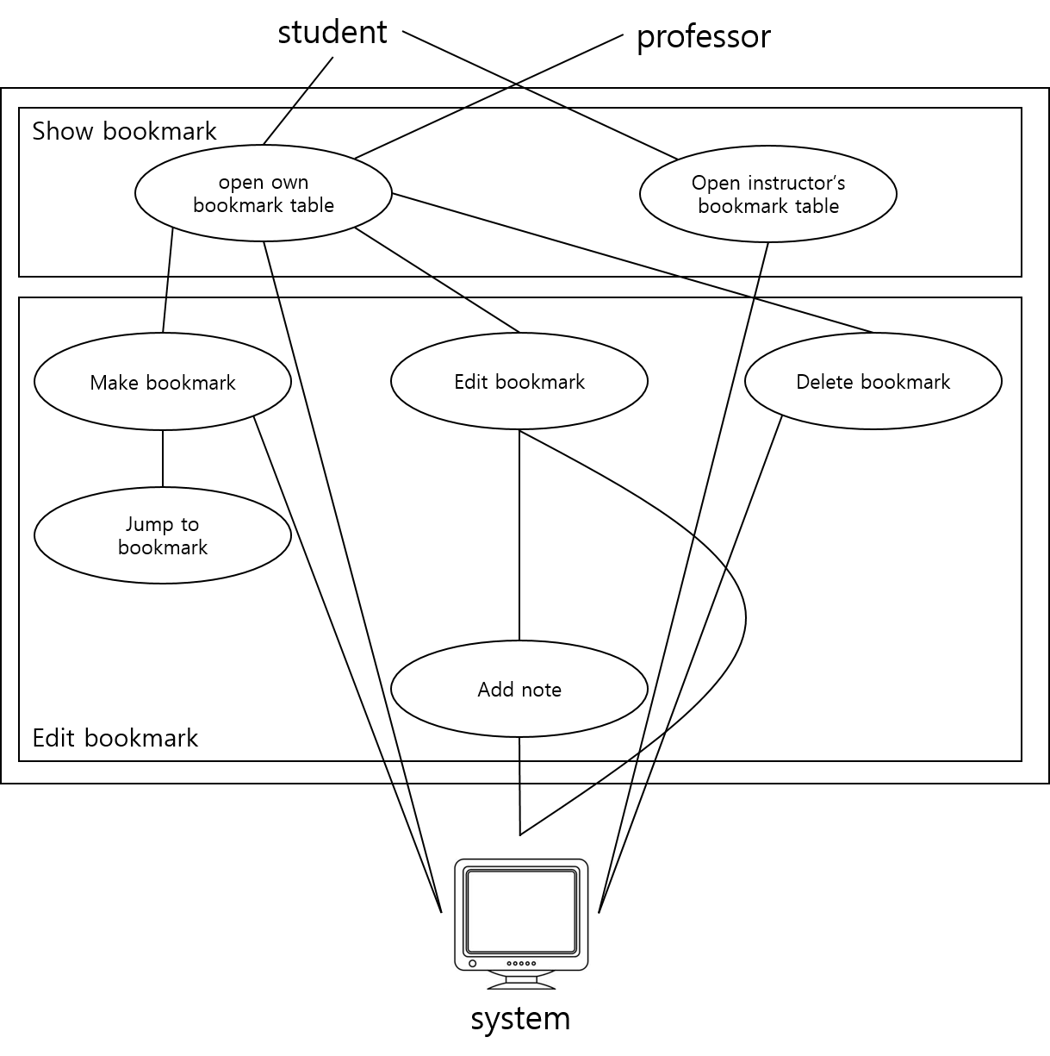

* + 1. Data Dictionary

[Table 21] learner

| **Field** | **Key** | **Constraint** | **Description** |
| --- | --- | --- | --- |
| learner_id | PK, FK | Not Null | Learner id(student number) |
| name |  | Not Null | Learner name |
| age |  | Not Null | Learner age |
| gender |  |  | Learner gender |

[Table 21] instructor

| **Field** | **Key** | **Constraint** | **Description** |
| --- | --- | --- | --- |
| instructor_id | PK, FK | Not Null | Instructor id |
| name |  | Not Null | Instructor name |
| major |  | Not Null | Instructor major |

[Table 21] learner_group

| **Field** | **Key** | **Constraint** | **Description** |
| --- | --- | --- | --- |
| group_id | PK | Not Null | Group id |
| subject_id |  | Not Null | Subject id |
| learner_id |  | Not Null | Learner id |

[Table 21] subject

| **Field** | **Key** | **Constraint** | **Description** |
| --- | --- | --- | --- |
| subject_id | PK, FK | Not Null | Subject id |
| subject_name |  | Not Null | Subject name |
| Insructor_id |  | Not Null | Insructor id |

[Table 21] lecture

| **Field** | **Key** | **Constraint** | **Description** |
| --- | --- | --- | --- |
| subject_id |  | Not Null | Subject id |
| lecture_id | PK, FK | Not Null | Lecture id |
| lecture_name |  |  | Lecture name |

[Table 21] video

| **Field** | **Key** | **Constraint** | **Description** |
| --- | --- | --- | --- |
| lecture_id |  | Not Null | Lecture id |
| video_id | PK, FK | Not Null | Video id |
| video_name |  |  | Video name |
| video_time |  | Not Null | Video time |

[Table 21] bookmark_learner

| **Field** | **Key** | **Constraint** | **Description** |
| --- | --- | --- | --- |
| bookmark_id | PK | Not Null | Bookmark id |
| learner_id |  | Not Null | Learner id |
| video_id |  | Not Null | Video id |
| time |  | Not Null | Bookmark time |
| is_note |  | Not Null | Note presence |
| note |  |  | Note content |

[Table 21] bookmark_instructor

| **Field** | **Key** | **Constraint** | **Description** |
| --- | --- | --- | --- |
| bookmark_id | PK | Not Null | Bookmark id |
| instructor_id |  | Not Null | Instructor id |
| video_id |  | Not Null | Video id |
| time |  | Not Null | Bookmark time |
| is_note |  | Not Null | Note presence |
| note |  |  | Note content |

